

**Ideas and Institutions – A Growth Story**

Speech given by

Andrew G Haldane Chief Economist Bank of England

The Guild Society University of Oxford 23 May 2018

The views expressed here are not necessarily those of the Bank of England or the Monetary Policy Committee. I would like to thank Shiv Chowla and David Ronicle for their help in preparing the text. I would like to thank Will Abel, Sandra Batten, Sarah Kinson and Patrick Schneider for their comments and contributions.

Economic growth has been among the greatest gifts given to us, as individuals and societies. It may no longer be fashionable to say so. Measures of economic growth, like Gross Domestic Product (GDP), can be highly imperfect metrics of how well individuals and societies are faring, their subjective sense of well-being.1 And growth in income and output is not, of course, an end in itself.

Nonetheless, it is now pretty well-established that growth is a vital ingredient, indeed pre-requisite, for meeting many of the broader societal objectives many would view as important to our longer-term health, wealth and happiness.2 While not an end in itself, economic growth appears to be a vitally important means of achieving those societal ends.

Economic growth is the main reason why global levels of poverty and rates of infant mortality have fallen spectacularly over recent centuries. It is why longevity and educational standards have risen secularly over the same period. And growth may even have contributed to the incidence of global conflicts and wars having fallen to their lowest levels, perhaps in human history.3

That makes growth a gift, one necessary (if not necessarily sufficient) to deliver secular improvements in living standards. And it is what makes a good understanding of the determinants and drivers of growth so crucial for societal progress. By understanding the forces driving growth, past, present and future, we can begin to devise and implement economic policies that support improvements in society.

I thought I understood the story of economic growth, its drivers and determinants. But recently I have changed my mind. I have a new story of growth. I think this story carries important implications for understanding the future challenges of technology and for devising the future policies and institutions necessary to meet them. That might require, among other things, a repurposing of successful institutions like this one, turning them from *uni*versities into *multi*versities.

# The Story of Growth

The story of economic growth often begins with a chart like this one (Chart 1). This plots the path of global economic growth, measured by Gross Domestic Product (GDP) per head, over the past 1000 years. And what a story it tells. It is a tale of two halves – or, more accurately, a tale of three-quarters and a quarter.4

For the first three-quarters of the past 1000 years, the global economy stood still in growth terms. GDP growth per head of population averaged less than 0.1% per year. Just try and imagine those rates of growth. They meant it took more than a millennium for living standards to double.

1 Stiglitz, Sen and Fitoussi (2009).

2 For example, Coyle (2014).

3 Two recent excellent books (Pinker (2018), Rosling (2018)) chart this and other dramatic improvements in societal well-being over time.

4 De Long (1998).

This growth experience is likely to have had an important psychological, as well as financial, impact. The average person would not see any improvement in living standards over their lifetime. Their lived experience was imperceptibly different than their parents, grandparents or indeed great, great grandparents. People’s lives were lived on a travellator. Rising living standards was not a social norm. Secular stagnation was.

You could argue, with some justification, that measures of GDP at this time might have been missing a trick. We did not have any formal, statistical means of measuring incomes and outputs in the economy until well into the 20th century, with the development of the National Accounts. And GDP anyway underplays important factors shaping people’s well-being, such as levels of nutrition, infant mortality and longevity.5

Yet, as best we can tell, alternative well-being metrics tell broadly the same story.6 Rates of infant mortality were unchanged over this period. Life expectancy flat-lined at 30 to 40 years. Levels of calorific intake stood still. And the global population scarcely budged, held in check by unchanged food supplies, as predicted by Thomas Malthus in the late 18th century.7 Not for nothing was this called the Malthusian era.

Another example of this secular stagnation, a favourite of mine, is provided by plotting heights from excavated skeletons records. These are a diagnostic on levels of health and nutrition. Male skeleton heights were essentially unchanged, at 160-170cm, for at least 2,000 years prior to 1750. Humans grew neither physiologically nor financially. And neither, then, did the societies in which they lived.

That makes the contrast with developments in the last quarter of the millennium all the more striking. From around 1750, GDP per head suddenly took off and has kept on rising ever since, growing by around 1.5% per year. The magic of compound interest means these growth rates have transformed people’s living standards. The time it takes for living standards to double has shrunk to less than 50 years.

The impact on people’s well-being, financial and psychological, has been transformational. It has meant each generation has been around 50% better off than its predecessor. After 1750, generational progress suddenly became visible, children to parents to grandparents. Growth in living standards became a social norm, in a way never previously true in human history. Life’s travellator turned into an escalator.

And not just for GDP. Broader metrics of well-being tell a similar tale. Rates of infant mortality have fallen by 40 percentage points since the end of the 18th century.8 The estimated lifespan of a human has risen by a factor of over two.9 And estimated male skeleton heights have risen by 5-10cm.10 Humans have grown, financially and physiologically, in lockstep. The world has moved from a Malthusian Era to a Golden one.

5 Stiglitz, Sen and Fitoussi (2009).

6 For example, Clark (2009).

7 Malthus (1798).

8 Our World In Data: <https://ourworldindata.org/child-mortality>

9 Our World In Data: <https://ourworldindata.org/life-expectancy>

10 Haldane (2015a).

# A Story with One “i”

What explains this extra-ordinary inflexion point in the history of economic growth and living standards? So fundamental is this question to so much of social and economic history that, understandably, it has attracted huge amounts of empirical, historical, social and theoretical research. Out of this cloud of evidence, a clear sunbeam of understanding has emerged about the deep causes and catalysts of economic growth.

If you ask a schoolchild what happened in England around the middle of the 18th century, as I often do, many will give you the right answer. It marked the dawn of the Industrial Revolution. But what exactly was this a revolution *in* and what exactly *caused* it? In the standard account, the catalyst for this revolution in economic growth came from a single source, from one “i” - ideas.11

In the second half of the 18th century in the UK, ideas began sprouting like morning mushrooms. These ideas emerged seemingly spontaneously and roughly contemporaneously. They were also relatively closely clustered geographically. They included James Hargreaves’ spinning jenny in 1764, Richard Arkwright’s water frame in 1769 and James Watt’s steam engine in 1775.

In the fullness of time, these ideas began to revolutionise both industry and work. After a lengthy adoption lag, they spread across sectors and across regions. They migrated from being mere ideas to becoming “GPTs” or General Purpose Technologies.12 In the process, they generated waves of investment in new factories, machines, processes and infrastructures. There was, in the jargon, capital-deepening.

Neo-Classical theories of economic growth are very clear what would be expected to happen next.13 When an outward shift in the economy’s technological frontier is combined with higher levels of physical capital, the fuse is lit on higher productivity among companies, higher wages among workers and, ultimately, higher living standards among societies. So it was during the Golden Era.

Chart 2 plots productivity, wages and GDP per head in the UK since the Industrial Revolution. All three plateaued prior to 1750. Since then, all three have moved up in lockstep. Ideas and innovation have borne continuous fruit in higher productivity, pay and living standards. This fruit has been shared roughly equally between owners of companies (profits) and workers in companies (wages). We know that because labour’s share of the national income pie is similar today to 1750.

Of course, it is not ideas and innovation from the 18th century that has sustained growth over the subsequent period. Although the innovation process is continuous, historians often point to three distinct waves – three Industrial Revolutions. The second came in the latter part of the 19th century with the emergence of GPTs

11 For example, Romer (1990) describes a theoretical model of growth based around innovation.

12 Bresnahan and Trajtenberg (1995).

13 For example, Mokyr (2011) discusses Britain during the Industrial Revolution.

such as electricity, the internal combustion engine and sanitation. The third came in the middle of the 20th century with new GPTs such as computing, digitisation and the internet.14

Yet in each case the playbook was familiar from the first Industrial Revolution. The emergence of a new strain of GPTs resulted in an outward shift in the production possibility frontier and capital-deepening. With higher levels of investment in physical and human capital, the productivity of companies, the wages of workers and the living standards of societies continued their Northerly ascent. The Golden Era continued.

Some people are now discussing the next innovation wave, a so-called Fourth Industrial Revolution. The GPTs driving this are likely to include Artificial Intelligence (AI), Big Data, automation, robotics, 3D-printing and nano-technology.15 I will return to the Fourth Industrial Revolution when discussing future growth.

# A Different Growth Story

As appetising as this growth story sounds, a reading of the history books make it difficult to swallow whole. It is certainly plausible to think that a divine coincidence of Hargreaves, Watts and Arkwrights, in roughly the same place at roughly the same time, resulted in a white-hot crucible of creativity. Indeed, we might be seeing that self-same crucible of creativity in Silicon Valley today.

But the Industrial Revolution was hardly the first firing of that crucible. We have, through history, seen many episodes of furnace-hot crucibles of innovation, spanning most continents and most centuries.16 Successful cities, regions, countries, continents and empires of the recent and distant past were often built and sustained on ideas and innovation and accompanying investment in machines and people.

The Roman Empire is a case in point. Some of you will remember the sequence from Monty Python’s *The Life of Brian* which begins with the rhetorical question: “What did the Romans ever do for us?” The sketch concludes: “But apart from better sanitation and medicine and education and irrigation and public health and roads and a freshwater system and baths and public order...what have the Romans done for us?”

You do not need to go that far back for examples of big ideas which had a transformative impact on industry and society. Immediately prior to the Industrial Revolution and running chronologically, these included the windmill in the 12th century, the mechanical clock in the 13th, the cannon in the 14th, the printing press in the 15th, the postal service in the 16th and the telescope and microscope in the 17th.17

It will surprise no-one that waves of innovation, big and small, have been lapping the shores of society for the entirety of human civilisation. In other words, while ideas and innovation may well be a necessary condition

14 Van Reenen *et al* (2010), for example, document the economic impact of ICT.

15 See Bughin *et al* (2017) and Haldane (2018), for example.

16 Flohr (2016), for example, discusses innovation in Roman society.

17 Clark (2009).

for economic growth, the historical record suggests they may not themselves have been sufficient. Other forces appear to have been at play, translating these ideas into sustained growth in living standards.

What might those forces be? I want to provide two different, but complementary, lenses on the growth story. The first focusses on a rather broader set of “capitals” – not just physical capital (plant and machines) but human (skills and expertise), intellectual (ideas and technologies), infrastructural (transport and legal systems), social (co-operation and trust) and institutional (national and civic, private and public) capital.18

History suggests each of these capitals may have played an important supporting role in the story of growth. Ideas alone, without the support of one or more of these broader capitals, have historically run aground. For example, in the UK many of the foundations for growth after the Industrial Revolution were laid in the centuries preceding it. It was on this platform of “capitals”, plural, that ideas and innovation then built.

Take human capital. The most dramatic improvements in educational standards in the UK occurred *prior* to 1750 (Chart 3). So too did the largest improvements in measures of social, infrastructural and institutional capital.19 Ideas needed these foundations to flourish. A steam engine is not much use without the skills to build it, the tracks to run it on, the institutions to oversee it, the trust of the public to accept it. The causes of the growth inflexion in 18th century England were as much sociological as technological.

Another lens through which to view this alternative growth story has recently been provided by economic historians, Steve Broadberry and John Wallis.20 Indeed it was probably this lens on the world, above all others, that led me to change my own story about growth. Broadberry and Wallis do two things.

First, they construct some new estimates of growth going back to 1300. Rather than relying on period averages, they use higher-frequency measures of growth. This changes the growth picture significantly. Period averages conceal large, long-lasting swings in growth over time (Chart 4). Their revised measures suggest growth did not flat-line prior to 1750, even though it averaged zero. Rather, growth oscillated wildly.

Second, given the scale and duration of these oscillations, they decompose their growth data into “expanding” and “contracting” periods. Chart 5 plots these for the UK over the past 700 years. A broadly similar pattern of expanding and contracting periods can be found in Spain, France, Italy, Portugal, and the Netherlands over roughly the same period. This decomposition changes the growth story radically.

Even prior to the Industrial Revolution, economies experienced notable periods of strongly positive growth. Between 1300 and 1700, GDP expanded slightly more than half the time. Over these expanding periods, growth averaged 5.3% per year. The reason average growth was far-lower over this earlier period – indeed,

18 Solow (1956), Mincer (1984), Romer (1990), Iyer, Kitson and Toh (2005), North (1990).

19 Haldane (2015a).

20 Broadberry and Wallis (2017).

little more than zero – was because expanding periods were almost exactly offset by contracting periods. They accounted for slightly less than half the period, during which growth averaged *minus* 5.4% per year.

So what has changed in the period since the Industrial Revolution? Growth during expansion periods is relatively little changed. Since 1750, it has averaged 3.2% per year. That is in fact a bit less than growth during expansion periods prior to the Industrial Revolution. This strongly implies it is not the greater incidence of ideas-fuelled booms after 1750 that accounts for the growth inflexion.

The explanation lies instead in the dramatic fall in both the probability and cost of GDP contractions. Recessions have occurred only 30% of the time since 1700 and only 17% of the time since 1900. During these periods, growth has averaged *minus* 2.2% per year since 1700 and *minus* 3.4% per year since 1900. Since 1750, recessions have become far less frequent and less painful. It is the avoidance of deep recessions that differentiates the Golden Era from its Malthusian predecessor.

Where does this leave our story of growth? Well, the story that better fits the facts appears to be one in which the conveyor belt of ideas and innovation has been continuous over the centuries, causing lengthy if lumpy ideas-fuelled expansions. But whereas prior to the Industrial Revolution this conveyor belt was regularly halted by recessions, more recently these interruptions have been far fewer and less costly.

Put differently, the real revolution in living standards after 1750 came about not exclusively, or perhaps even mainly, from the surge in ideas and technologies. Rather, it resulted from societies having found some means of avoiding the subsequent recessionary bullets. Prior to the Industrial Revolution, these killed expansions dead. After it, societies appear to have found some effective means of dodging them.

# A Second “i” on Growth

To understand growth, then, we need to explain why economies become less recession-prone after 1750. For me, the explanation lies in a second “i” – institutions. I will argue that it was the emergence of institutions that explains the rise in the other capitals that were essential pre-conditions for growth (human, social, infrastructural, intellectual etc.) It was the emergence of these same institutions which also cushioned the damaging effects of recessions. As with sight, to gain a true perspective on growth you need two “i"s.

This is, in one sense, not a new story. A number of distinguished economists have, over the years, placed institutions centre-stage in explaining secular trends in social and economic development. They include classical economists such as Adam Smith and John Stuart Mill and, more recently, Nobel Laureates such as Ronald Coase and Douglass North.21 Broadberry and Wallis themselves conclude that the most likely cause of fewer downside growth surprises since the Industrial Revolution has been the rise of institutions.

21 Smith (1776), Mill (1848), Coase (1960), North (1991).

Empirical work supports the institutional hypothesis. Cross-country growth regressions suggest nations with high-quality institutions out-grow those without.22 Detailed country case studies reach a similar conclusion. For example, institutional quality has been used to explain the very different economic fortunes of North and South Korea after separation. The absence of institutions is, for some, *Why Nations Fail*.23

If institutions hold the key, what exactly do we mean by them and how exactly do they come about? Douglass North’s definition is a good starting point: “humanly devised constraints that structure political, economic and social interactions”.24 So defined, institutions are *social infrastructure*. They include formal or legal institutions, like Parliaments, judiciaries, central banks, social safety nets and schools. But they also include less formal associations and groups, such as universities, trade unions, guilds and charities.

As for their genesis, history suggests institutions emerge for a variety of reasons. Sometimes they have been a direct response to political upheaval. Some of the largest transformations in political institutions have resulted from revolutions: in the UK, after the Glorious Revolution of the 17th century, in France after the French Revolution of the 18th century, in the United States after the Civil War of the 19th century.

At other times, institutions have emerged in response to the pressing financial or social needs of citizens. Often, those times of most pressing financial and social need have coincided with sharp changes in the economic environment which have left large swathes of society worse-off. And often, technological disruption and displacement have been the root cause of these sharp changes in the economic environment.

The three Industrial Revolutions provide a useful set of case studies. Each caused technological disruption and significant job displacement. Each had, as a result, a wrenching and lasting impact on the job and income prospects of large swathes of society. Each caused a significant and sustained period of hardship for many.25 And each caused a stretching of the social fabric, often to close to breaking point.

It is now well-established that each industrial revolution caused a significant loss of livelihood for workers whose set of tasks was most susceptible to automation. The upshot, often, has been a “hollowing out” of jobs across the skill distribution.26 Because reskilling and retraining takes time and effort, job displacement worsens pay prospects for a great many, significantly and persistently.27 And these losses were often made worse because they were concentrated occupationally and geographically.28

A second, accompanying adverse side-effect of technological disruption has often been rising levels of income inequality. Historically, those skilling-up to keep one step ahead of the machine saw demand for

22 Levine and Renelt (1992).

23 Acemoglu and Robinson (2012).

24 North (1990).

25 Haldane (2015b).

26 Katz and Margo (2013), for example, show that skilled blue collar employment in US manufacturing declined while white collar and unskilled manufacturing employment increased.

27 Autor (2017) documents lower relative wages for those in US most exposed to international competition.

28 Autor (2017).

their skills rise and, with it, their wages. By contrast, those at the other end of the skills distribution saw their incomes fall, due to reduced demand and increased supply of their skills. The resulting rise in income inequality has tended, historically, to heighten popular discontent and worsen social cohesion.

A third adverse side-effect was that workers did not always benefit, fully or immediately, from technologically-induced gains in companies’ productivity and profitability. In the early stages of each industrial revolution, wages tended not to rise in line with productivity, causing labour’s share of the national income pie to fall.29 This, too, tended to add to popular discontent and damage social cohesion. Labour’s income share has also fallen in a number of advanced economies over the past few decades.30

A final side-effect is that periods of technological transition were often lengthy as well as painful. In the first Industrial Revolution, many displaced workers had still to find alternative work by the middle of the

19th century, with income inequality running high and labour’s share falling. This period is known by historians as “Engel’s pause”.31 Subsequent industrial revolutions have seen similar, if less long-lived, pauses.

If economic hardship is widespread and social cohesion damaged, a societal response is needed. One such response is the creation of new pieces of social infrastructure – in other words, institution building. Each industrial revolution saw a surge in such institution-building, to cushion the adverse side-effects of technological change on jobs and pay. In this way, the recessionary hit to workers and the economy could be shortened or dampened. Broadly speaking, two such sets of institution emerged.

One set equipped workers with the new skills they needed to thrive in a new jobs environment. It was only by acquiring these skills that workers could transition to where new jobs were being created. By keeping one step ahead of the machine, technological unemployment could be avoided. A shorter, more seamless skills transition reduced the hit to workers’ incomes and lowered the risk of skills atrophy, which might otherwise cause lasting damage to employment. This social infrastructure might be called “enabling” institutions.

Another set of institutions provided workers with support to cushion the hit to their finances and well-being during the painful and lengthy period of job transition. This might be financial support, in income or loans. It might be housing or shelter. Or it might be social or emotional support. This social insurance ensured that lives were underpinned, inequalities held in check and the social fabric held together. It reduced recession risk, for individuals and for societies. These might be called “insuring” institutions.32

29 Allen (2005) documents the stagnation of real wages in Britain from 1800 to 1840.

30 IMF (2017).

31 Allen (2009) discusses Engels’ pause in the context of the British economy from 1760 to 1913.

32 Of course, many other institutions played a role in the labour market beyond the “enabling” and “insuring” ones mentioned here. For example, the ‘Poor Laws’ in the 1800s meant that the poor had to enter workhouses with terrible conditions to receive help in the form of clothes and food.

During the first three Industrial Revolutions, the skills workers needed to keep one step ahead of the machine were largely cognitive. Machines undertook largely manual (“doing”) tasks, which had previously used labour-intensive technologies. Cognitive (“thinking”) tasks remained, by and large, the exclusive domain of humans. So institutions emerged to nurture thinking skills, largely in children and young adults, to increase the chances of successful transition to the cognitively-intensive future world of work.

In children, the most important of these institutional innovations was probably compulsory schooling. For children between the ages of 5 and 10, this was formally introduced in the UK with the Elementary Education Act of 1880. It was extended to age 11 in 1893 and age 12 in 1899. The Fisher Act of 1918 provided for compulsory education to age 14 and part-time education to age 18. Compulsory full-time education was extended to age 15 in 1947 and age 16 in 1972.33

As these pieces of social infrastructure developed, so too did standards of educational attainment and cognitive skills. The fraction of the population aged 15 and over that attended secondary school rose from 23% to 60% between 1950 and 2010.34 In the 1950s, less than 11% of the relevant age group passed five or more GCSE O levels in England and Wales. By 2010, that had reached almost 80%.35

Beyond age 18, there was in parallel a rise in both numbers and attendance at universities. For over six hundred years from 1209, England had only two universities – this one (Oxford) and the other one (Cambridge). It was not until the formation of University College London in 1829 that their duopoly was broken. And it was not until the 20th century that some of the other main cities – Manchester, Liverpool, Leeds, Bristol, Birmingham and Sheffield – established their own universities.36 Today, there are around 130 universities in the UK as a whole.

Participation rates in higher education have also undergone a secular rise and, latterly, a revolution. The share of young people attending university has increased from just over 3% in 1950 to over 8% in 1970, over 19% in 1990, 33% in 2000 and 49% by 2016.37 Having been less than 5,000 in 1920, the number of first degrees obtained at UK universities had increased to over 365,000 by 2016. 38

Through the rapid rise in school and university attendance, there was a revolution in cognitive skills in the workforce. That provided the human capital necessary to turn new technologies and machines into higher levels of productivity among companies, higher wages among workers and, ultimately, higher living standards among societies. Put differently, higher cognitive skills reduced the odds of a lengthy recessionary period of technological unemployment for many individuals and societies.

33 Legislative dates for compulsory schooling vary from dates of enforcement.

34 Barro-Lee Educational Attainment Dataset: <http://www.barrolee.com/>

35 Bolton (2012).

36 Willetts (2017).

37 Bolton (2012) for data from 1950 to 2000. 2016 data from Department of Education.

38 Bolton (2012) and Universities UK (2017). Refers to full-time first degrees only.

Raising levels of skills and training for workers is one way of limiting the costs of technological disruption. Providing them with access to finance or housing is another. This support helped smooth the hit to incomes and lifestyles brought about by job displacement. Starting in the late 18th and early 19th centuries, at the dawn of the Industrial Revolution, financial institutions began to emerge to provide financial support through bridging loans, often operating on collective or co-operative principles. In the UK, the Friendly Societies Act of 1819 established today’s credit unions. The Regulation of Benefit Building Societies Act followed in 1836.

Other sets of institution emerged to support workers in wider ways. Trade unions grew in importance during the 18th century, as workers’ jobs were hollowed-out and their share of the income pie was consumed.

Unions gained rights progressively during the 19th century, culminating in the foundation of the Trade Union Congress (TUC) in 1868. The Trade Union Act of 1871 gave unions fully-fledged legal status.

Trade unions helped workers by campaigning to protect their rights, improve their conditions and boost their bargaining power in the workplace. They also provided direct financial support to unemployed workers, through an early form of unemployment insurance, to smooth the income consequences for workers of job loss. The National Insurance Act (1911) and the Beveridge Report (1942) subsequently made this a responsibility of the state and put it on a comprehensive footing.

This was part of a wider-ranging shift in the role played by the state in society from the 17th century onwards. State spending as a proportion of national income rose from around 1% in the 16th century to around 12% in the 18th, 14% in the 19th and 33% in the 20th.39 It financed social infrastructure of various kinds supporting those facing greatest hardship. This ranged from social housing to healthcare to income support. Its effect was to cap the downside, recessionary risk to individuals, economies and societies.40

Another form of institutional support came from the creation of state-owned and/or central banks. The Bank of England was set up at the end of the 17th century to manage the government’s debt and safeguard the nation’s currency and finances. Over the course of subsequent centuries, this role has expanded. Since at least the middle of the 19th century, the Bank of England has become one of the key institutional safeguards against recession risk and financial crisis.41 Indeed, today, those roles are defined in statute.

Non-state institutions have also played an important role in protecting those facing the adverse side-effects of economic change. This included many religious, philanthropic and charitable organisations and citizen movements that emerged from the 18th century onwards, often as a direct response to hardship brought about by technological change. These institutions offered, and many continue to offer, a combination of financial, housing, training and emotional support to those in need.

39 Clark (2009). Figures refer to government command of output as a percentage of GNP in England.

40 Other 19th century legal changes that supported individuals from adverse side-effects of economic change included recognition of limited liability companies and constraints on the ability of courts to sentence debtors to prison.

41 Anson *et al* (2017), for example, discuss the emergence of the Bank of England as lender of last resort.

To mention one, the Young Men’s Christian Association (YMCA) was founded in 1844, at around the time of Engels’ pause. It was established explicitly to meet the housing and social needs of young men who had moved from rural towns and villages to find work in factories in the cities. It soon grew into a regional, and in time global, network offering financial, housing, training and social support, to both men and women, cushioning the recessionary hit to societies. And that remains its role today.

The story, then, is of a social infrastructure emerging to support workers and societies buffeted by technological change. These institutions aimed either to reduce the length or to limit the costs of adjustment by displaced workers. By enhancing skills and mitigating hardships, the incidence and cost of recessionary adjustment was reduced, for individuals and societies. And this, ultimately, was the difference between the living standards escalator of the Golden Era and the travellator of its Malthusian predecessor.

Joseph Schumpeter spoke powerfully about the forces of “creative destruction”.42 The lesson of history seems to be that we need both to “cultivate the creative” and to “disarm the destructive” if innovation is to translate into rising levels of social, human and infrastructural capital and, then, higher living standards. It is only by establishing strong institutional roots that technological fruit can subsequently be harvested.

# Future Growth and Future Institutions

From the past and present to the future. What lies in store for *future* economic growth? It is difficult to know with any confidence. But if history is any guide, the story of growth will hinge on the interplay between the two “i”s – the disruptive forces of innovation on the one hand, the stabilising role of institutions on the other.

There is an active debate underway on the first of these – the likely future path of innovation. Some have recently argued that the pace of innovation may be declining.43 The argument here is that many of the

low-hanging fruit from the ICT revolution have already been picked. Diminishing returns to R&D may have set in. And other secular forces – including adverse demographics and rising inequality – may have acted as additional headwinds to growth.44 This view sometimes goes by the name secular stagnation.45

An alternative school of thought believes we may instead be on the cusp of a new great wave of innovation, a Fourth Industrial Revolution.46 This revolution in innovation will, it is said, be jet-propelled by a set of potentially new GPTs, among them AI, Big Data and robotics. For technology optimists, the story is one of secular innovation, not stagnation. And on this view, the potential gains in productivity and growth could be as large as any of the earlier industrial revolutions.47

42 Schumpeter (1942).

43 Gordon (2012), Fernald (2014).

44 Summers (2013) and Rachel and Smith (2015).

45 Secular stagnation theory was originally proposed by Hansen (1938) in the aftermath of the Great Depression

46 Brynjolfsson and McAfee (2014) discuss ‘The Second Machine Age’.

47 Brynjolfsson, Rock and Syverson (2017).

Typically, the two sides of this argument are taken to be in a secular struggle: the dark forces of secular stagnation pitted against the dynamic forces of secular innovation. Yet in practice, both arguments have merit. They are certainly not mutually incompatible. It is perfectly possible to imagine a world of rapid innovation which nonetheless leaves large swathes of society in its slipstream. More than that, recent research suggests this is a likely outcome of the Fourth Industrial Revolution.

There are good conceptual grounds for thinking the displacement effects of the Fourth Industrial Revolution may be larger than ever-previously. Every industrial revolution has resulted in a hollowing-out, typically of mid-skilled tasks. Historically, that has meant largely manual, labour-intensive tasks. Machine has replaced human in activities that are routine and repetitive.

The future could well be very different. For example, the dawning of AI means that humans will no longer have the cognitive playing field to themselves. Thinking or non-routine tasks may increasingly be taken up by machines. They will be able to process more quickly, more cheaply and with fewer errors than their human counterpart, at least in some activities. That could make the hollowing-out of human tasks, now cognitive as well as manual, far greater than ever before.48

A cottage industry has emerged over recent years manufacturing estimates of job loss that might result from this rise of the robots. As an early contributor to this industry, I am at least partly to blame.49 The estimates of gross job loss span a pretty wide range, but lie anywhere between 10% and 50% of the global workforce, depending on whether it is jobs or tasks that are assumed to be displaced (Table 1 summarises).

Even at the lower end of this range, the societal impact would be significant. At the upper end, they would be truly transformative. If the truth lies in between, this could still make the jobs loss from the Fourth Industrial Revolution greater than its predecessors. And if so, then the potential societal costs – such as rising wage inequality and threats to social cohesion – could also be as great as ever previously.50

Some of the potentially powerful effects of automation on jobs and wages are already apparent. In the US, each industrial robot per thousand workers has been found to reduce the employment rate by

0.2-0.3 percentage points and wages by 0.25-0.5%.51 In Europe, results are more mixed.52 Research suggests that technology may have been the largest single contributor to falling labour shares over the recent past.53

Whether these effects on jobs and pay will be temporary or permanent is far harder to judge. At this stage of the technological cycle, the evidence is more likely to be picking up the shorter-term displacement effects of

48 Haldane (2015b)

49 Haldane (2015b).

50 Schwab (2017).

51 Acemoglu and Restrepo (2017).

52 For example, Dauth, Findeisen, Südekum and Woßner (2017).

53 IMF (2017).

technology than their positive longer-term effects on pay, productivity and the demand for new goods and jobs. It is the balance of these two effects, each large in gross terms, which will ultimately determine where unemployment will settle.54

No one could say with confidence today the long-run net effect will be. What can be said with confidence is that the scale of gross displacement may be larger than ever-previously. This means that, if technological unemployment is to be avoided, positive effects on productivity, goods and jobs will also have to be commensurately larger. That has led some to argue that technological unemployment is more likely this time around.55

Even if it is avoided, the societal costs of transition could well be larger, in terms of rising wage inequality, a falling labour share and damage to social cohesion. And if that recessionary impact of technological change on individuals and societies is sufficiently large, it could well call into question the merits of having pursued the creative course in the first place. Or that, at least, is the lesson of history.

What experience since the Industrial Revolution has taught us is that this risk can be mitigated by an appropriate institutional response. To be effective in curbing recession risk, that response should have as its objectives, first, speeding-up the process of reskilling by workers (“enabling”) and, second, cushioning the impact of new technologies on displaced companies and their workers (“insuring”).

In the face of mounting concern about the societal impact of the rise of the robots, quite a lot has been written recently on the sorts of new insurance mechanism that might be required to smooth this transition.56 Here, I will focus on two areas where new “enabling institutions” could ease the transition for workers and companies. Both draw on one of the greatest institutional inventions of the past millennium – universities.

In 1852, John (later Cardinal) Newman published *The Idea of a University,* a book that has since assumed classic status as a statement of the principles by which universities should be run and organised. There are many themes to that text. From these, I would highlight two which have particular relevance to the debate about the future role of universities within our societies.

First, Newman emphasised universities’ role in providing a liberal education for students, by which he meant access to a range of disciplines. Rigid specialism was to be avoided. The capacity to think was what mattered. Second, the role of the university was to propagate ideas, rather than necessarily generate them. The capacity to diffuse knowledge, rather than generate it, was what mattered. With a twist, both are relevant to the *Idea of a University* in the 21st century. David Willetts, for example, emphasises the role of universities with just as much vigour as Newman in his recent book, *A University Education*.

54 See, for example, Acemoglu and Restropo (2018) for an organising theoretical framework.

55 For example, Acemoglu and Restrepo (2017), Susskind and Susskind (2015).

56 Martinelli (2017) and Standing (2017), for example, discuss universal basic income.

1. *Human Capital*

Let me start with human capital, workers’ skills and experience. Two fundamental shifts in the jobs and skills market are likely in the period ahead. The first is demographic. A young person born today can be expected to live a 100-year life.57 That being the case, it is likely they will have a career of 60, perhaps 70, years.

Given changes to the future world of work, multiple changes of career, not just job, are likely during a lifetime. This has never before happened in human history.

The second secular shift is in the demand for skills. In the past, this skill-shift has been uni-directional. There has been a secular rise in demand for cognitive skills and a corresponding decline in demand for technical skills involving routine and repetitive tasks. That is why cognitive skills have attracted a rising wage premium (Chart 6). Put differently, demand for skills of the “head” (cognitive) have dominated those of the “hands” (technical) and, to lesser extent, those of the “heart” (social) over the past 300 years.

In the century ahead, those skill-shifts may be about to go into reverse. To see why, we need to ask ourselves what sets of humans’ skills robots are likely to find it hardest to reproduce and replace in the period ahead. My reading of the runes is that there are three areas where humans are likely to preserve some comparative (if not always absolute) advantage over robots for the foreseeable future.

The first is cognitive tasks requiring creativity and intuition (“heads”). These might be tasks or problems whose solutions require great logical leaps of imagination rather than step-by-step hill-climbing. Existing machine learning algorithms allow huge numbers of solution permutations to be tried quickly and costlessly. This allows these hill-climbing algorithms to scale local peaks in record time.

Whether they scale global peaks is altogether another matter. It is harder for machines to solve problems where it is difficult to define the solution steps in a logical sequence in advance. Humans call solutions arrived at in this way “intuition”. Despite rapid progress in deep learning techniques, it remains far-harder to devise search algorithms which solve problems requiring a leap into the unknown.58

Even in a world of super-intelligent machine learning, a demand is still likely to exist for people with the skills to programme, test and oversee these machines. Some human oversight and judgemental overlay of these automated processes is still likely to be needed. Machine design, improvement and oversight require, at least for the moment, humans and machines to operate in partnership.

The second area of prospective demand for humans skills is bespoke design and manufacture (“hands”). Routine technical tasks are relatively simple to automate and are already well on their way to disappearing.

57 Gratton and Scott (2016).

58 AlphaGoZero is one such attempt. It is an updated version of AlphaGo, a computer programme that plays the game ‘Go’, which itself was the first software to beat a human professional player in full match.

But the same is not true of non-routine technical tasks – for example, the creation of goods and services that are distinctive in their design, manufacture or delivery.

A rise in global wealth and income is likely to create an increasing demand for luxury goods and services of this type, whose characteristics are unique and supply constrained. Indeed, this can be seen already in the rising demand and price of rare art and artefacts and independently-produced foodstuffs and beverages. To meet this demand, Mark Carney has spoken about the re-emergence of a new artisan class. If so, this would mark something of a return to our pre-industrial revolution future.59

The third, and perhaps the biggest potential growth area of all, is social skills (“hearts”). That is, tasks requiring emotional intelligence (such as sympathy and empathy, relationship-building and negotiation skills, resilience and character) rather than cognitive intelligence alone. These are skills a robot is likely to find it hard to replicate. And even if they could replicate them, humans might still prefer humans to carry them out.

The future could see a world of work in which EQ rivals IQ for skill supremacy. Professions involving high degrees of personal and social interaction – such as health, caring, education and leisure – could see demand rise. Indeed, it is possible the balance between cognitive and social skills might alter significantly even among jobs which traditionally have been cognitively-intense.

Take medicine. The doctor of the future might be valued far less for their clinical competence in diagnosing illness and prescribing solutions. In a world of individual medical records and data-hungry diagnostic algorithms, much of the process of diagnosis and prescription might fall to machine rather than human.

Indeed, the UK Prime Minister has recently suggested a strategy to deliver just that.60

But that is unlikely by itself to eradicate the need for doctors. Patients are still likely to want to discuss their diagnosis and prescription. And they will want this advice delivered personally and empathetically. In surveys of patient satisfaction it is a doctor’s bedside manner, rather than clinical competence, that matters most.61 In future, that balance between social and clinical skills may shift further. And, most likely, those social skills will be demanded from flesh-and-blood rather than robo-doctors.

If both the nature of a career and the skills it requires are changing, does this carry implications for educational institutions? That seems likely. For decades, the primary focus of these institutions has been on providing young people with cognitive skills. That model has worked well in meeting the needs of the

skill-shifts seen through each of the three industrial revolutions.

59 Carney (2016).

60 PM speech on science and modern Industrial Strategy, available here: [https://www.gov.uk/government/speeches/pm-speech-on-](https://www.gov.uk/government/speeches/pm-speech-on-science-and-modern-industrial-strategy-21-may-2018) [science-and-modern-industrial-strategy-21-may-2018](https://www.gov.uk/government/speeches/pm-speech-on-science-and-modern-industrial-strategy-21-may-2018)

61 For example: <https://vanguardcommunications.net/doctor-online-review-study/>

Whether that model will meet the needs of the Fourth Industrial Revolution seems more questionable, for two reasons. First, in future it seems very likely young and old alike will be in equal educational need – to train, retrain and retrain again through their 60 or 70-year careers. Second, the skills these people require for the future world of work will no longer be cognitive. Rather, they are likely to be more evenly balanced between the cognitive, technical and social – head, hands and heart.

It has become rather trite to talk of the need for “life-long learning”. But never has the need for such learning likely to have been greater given the longer span and greater volatility in future career paths. Making these career transitions will itself call for a particular set of skills – personal resilience, problem-solving and flexibility. As is now well-recognised, these character attributes are best instilled in early years.

If we now turn to our existing universities and colleges, at present these do not appear to be ideally sited to meeting either of these secular shifts in educational and training need. By and large, they are not currently configured as centres for life-long learning. And nor, in the main, are they institutions providing a balanced educational offering of cognitive, technical and social skills.

To meet the needs of the future world of work, that might need to change. The importance of a broad-based, Newman-style, education is likely to be greater than ever. This might criss-cross disciplinary boundaries, as one way of increasing people’s ability to make giant logical leaps. Those skills will be social and technical every bit as much as cognitive, with head, hands and hearts sharing equal billing.

Put this way, the future university may need to be a very different creature than in the past. It may need to cater for multiple entry points along the age distribution, rather than focussing on the young. And it may need to cater for multiple entry points along the skills spectrum, rather than focussing on the cognitive. It would, in short, need to be plural rather than singular – a “multiversity”, rather than a university.

1. *Intellectual Capital*

Multiversities are about spreading future skills across the workforce. Another educational challenge is how to spread future technologies across companies. This is crucial if ideas and innovations are to become GPTs, boosting productivity, pay and living standards. At present, evidence on the diffusion of new technologies across firms paints a rather mixed picture.

To understand why, it is useful to recognise that two forces are at work when a new idea is diffusing through the economy. First, there is adoption (or extensive margin) – the time it takes a new technology to first reach a country or company. Second, there is penetration (or intensive margin) – the extent to which this technology then reshapes processes and products within a company or country.62

62 Comin and Mestieri (2013a).

Take an example like computing technology or robotics. The adoption lag would measure the time it took for a country or company to have their first computer or robot. The penetration rate would measure how many computers or robots the country or company had and how intensively they were used. You would expect both to be important to the process of technological diffusion and to boosting productivity. And, empirically, both are typically found to be important to these processes.63

So what does the evidence suggest about these twin diffusion processes? Looking at adoption lags of a range of different technologies across countries, the time-series evidence suggests these have fallen over time. Average adoption lags have shrunk from over a century in the 18th century, to perhaps 40-80 years in the 19th century and 20-50 years in the 20th century.64 It seems possible these lags may have fallen further entering the 21st century, with cross-border flows of information and ideas having risen to new heights.

This is a good news story for productivity. Indeed, one of the key benefits of globalisation over the past several decades is that the freer flow of goods and services, people and capital, ideas and information, has served as a vehicle for the transmission and diffusion of new technologies across borders. Other things equal, this should have accelerated catch-up between countries operating at and inside the technological frontier.65

Other things, however, have not been equal. Penetration rates of new technologies, once adopted, tell a different tale. They suggest that, over time, there has been a divergence between frontier and non-frontier countries. In other words, the intensity with which new technologies have been used has expanded more rapidly in frontier (especially Western) economies than in non-frontier (non-Western) ones. This will have retarded catch-up between the two blocs. It is a less encouraging story about the diffusion of innovation.

With the intensive and extensive margins of diffusion pushing in opposite directions, which has won out? It seems to have been the forces of divergence: slower rates of penetration of new technologies have more than counter-balanced faster rates of adoption across countries. This has shown up in levels of productivity between frontier and non-frontier which, since around 1980, have if anything diverged.

Chart 7 illustrates that. It compares levels of productivity across 44 countries since 1950 relative to the frontier country (the US). Convergence prior to 1980 has given way to divergence subsequently. That divergence in levels of productivity has, in turn, translated into divergence in levels of GDP per head across countries over the same period.66 The process of livings standards catch-up has stalled, possibly reversed. And the reason for that appears to be a slowing in rates of technological diffusion.

63 Comin and Mestieri (2013a).

64 Comin and Mestieri (2013b).

65 Baddeley (2006).

66 Comin and Mestieri (2013b).

If there has been a slowing in rates of technological diffusion *across* countries, is the same potentially true *within* countries? Evidence using micro-level company data within countries suggests it is. Research by the OECD suggests there has been a slowing in rates of technological diffusion across firms in a number of countries.67 Put differently, there is a long and lengthening lower tail of companies failing to keep pace with the technologies used in frontier companies. Their productivity performance has fallen ever-further behind.

This widening dispersion in the performance of upper and lower tail companies appears to be a particularly acute in the UK. To a greater extent than elsewhere, it appears that the UK is a tale (or tail) of two companies. At the upper end, the UK seems to have as many high-productivity companies as its main competitors (Chart 8). That fits with the UK’s standing as a global innovation hub, with world-leading companies and universities and high indices of innovation by international standards.68

That is more than counter-balanced, however, by productivity performance in the lower tail. This tail appears to be both materially longer and lower than the UK’s main international competitors (Chart 8). Moreover, this lower tail has lengthened by more over the past decade than in those other countries.69 The already slower rates of technological diffusion in the UK, by international standards, have slowed further over the recent past.

These diffusion dynamics are important to productivity and living standards. The wider dispersion and longer lower tail of companies helps explain the UK’s roughly 30% productivity gap with, say, France and Germany. And the widening dispersion in productivity performance between the upper and lower tails of companies helps explain the UK’s relatively poorer productivity performance than these countries over the past decade.

These diffusion dynamics are also consistent, or at least are not inconsistent, with the dawning of a Fourth Industrial Revolution. This will have had the effect of shifting outward the technology and productivity frontier for pioneer firms. There is clear evidence of that having happening. Productivity among firms in the top 1% of the distribution grew, on average, by 8% per year over the ten years to 2014. The most-productive 0.1% of firms exhibited 12% annual growth.70

As a point of comparison, the lower 99% tail of firms have experienced annual average productivity growth of less than 1% over the same period. In other words, looking at a cross-section of UK companies, secular innovation (for the upper 1% or 0.1%) has co-existed with secular stagnation (for the remaining 99%). The two are engaged, not so much in a secular struggle, as a secular stand-off. Technological diffusion, and hence productivity growth, has been the casualty.

67 Andrews, Criscuolo and Gal (2016).

68 Department for Business, Energy & Industrial Strategy (2017).

69 Haldane (2017).

70 Productivity figures refer to the non-financial business sector, but other sectors for which data are not available over the full ten-year period are also omitted.

There have been one or two recent studies which have been quoted as questioning the importance of this “long tail” issue for the UK.71 These pieces use the same data used here. The problem arises not from the data but from the (mis)interpretation placed on them by these studies. All of these studies show, very clearly, that the UK has a significant long tail problem. Appropriately defined, they also demonstrate that this tail has lengthened during the course of the crisis.

To give one example, my Bank colleague Patrick Schneider recently published a blog post showing that a good chunk of the slowing of productivity growth since the crisis could be accounted for by workers in the top quartile of the productivity distribution.72 This is entirely consistent with the tale of two companies. Indeed, it is evidence of the lower tail of companies with flat-lining productivity having lengthened during the crisis and by more in the UK than in competitor countries, consistent with the long tail hypothesis.

Why might the UK’s long tail, and hence technological diffusion, problem be more acute than elsewhere? Several reasons have been posited and probed.73 One interesting window on this issue is provided by looking at the intensive and extensive diffusion margins, to see if these provide clues. Looking at a range of ICT technologies, the data suggests that high and relatively consistent levels of technological adoption, but low and variable rates of technological penetration, mimicking the international evidence.

Take internet access. Almost all UK businesses – in excess of 90% – now have internet access. But the UK ranks poorly compared to other OECD countries in terms of broadband penetration (Chart 9).74 That is true not only for standard broadband connectivity, but also for more advanced infrastructure such as optical fibre connections. Those low rates of penetration largely reflect large/small firms differences. As with other OECD countries, broadband usage by large firms is almost 100%. But for smaller firms that falls to 93%.

Similarly, the share of UK businesses with a website is above the OECD average, at around 83%. But that masks sizable large/small firm differences. Almost 100% of UK large firms use websites, which has been the case for a decade. Only two-thirds of small firms had a website in 2007. One may have expected that gap to close rapidly. Even today, however, only around four-fifths of small firms have a website.

E-commerce is another technology that has arguably been surprisingly slow to propagate through the UK economy. In 2016, over 80% of UK individuals ordered goods or services online, more than any other OECD country. One may have expected that to have been mirrored by a large share of UK businesses selling online. In practice, the UK is only marginally above the OECD average. And between 2009 and 2016, the share of UK businesses making e-commerce sales increased by only 6pp, from 17% to 23%.

71 Swinney (2018), Giles (2018).

72 Schneider (2018).

73 Haldane (2017), Jacobs *et al* (2017), Swinney (2018), for instance.

74 OECD data.

If the story, then, is one of diffusion dynamics being more sluggish in the UK than elsewhere, what might be done to improve matters? Institutions, and within that universities, may well have a role to play. At present, a relatively small sub-set of the UK’s universities operate as innovation hubs. They conduct world-leading research using world-leading researchers. And, in an increasing number of cases, they are doing so in tandem with businesses in spin-off science parks, acting as incubators of innovation.

What the UK may lack is some diffusion spokes to accompany these innovation hubs – spokes that could help spread new and existing technologies, new products and practices to the long and lengthening lower tail of companies. To be successful, these spokes would need to be repositories of knowledge and expertise on technologies and their application to companies. And, ideally, these repositories would have regional and sectoral reach to enable them to touch the long tail.

The UK’s existing university network would be one institutional solution to this spoke problem. They have regional and sectoral reach. They also have embodied expertise and knowledge. By working in partnership with local businesses, they could serve as repositories of expertise on good company practices – in management, organisation, logistics, robotics, AI and the like. A new set of business parks attached to these universities could serve, not so much as innovation incubators for new companies, but as diffusion clinics for existing ones.

This idea goes with the grain of the earlier proposal; it would broaden the scope and purpose of universities. In future, these would develop a broader set of capitals – beyond human capital (in people) to include physical and intellectual capital (in firms). And they would do so throughout the lifecycle of companies, not just in their early years. As it happens, this would also be consistent with Newman’s original conception of universities as diffusion-engines, every bit as much as innovation-engines.

In Germany, a network of applied research institutes, run jointly by universities and industry, has been in place since 1949. The Fraunhofer institutes now total 72.75 Their extensive project work means they can apply technological solutions quickly to a wide variety of firms. Each year, they engage in between

6,000-8,000 projects, large and small, with companies. The Fraunhofer have been found to play a vital role as both innovation hubs and diffusion spokes, boosting productivity in the German economy.76

Since they first become operational in 2011, the UK now has around 10 Catapult centres, modelled on the German Fraunhofer. These are smaller in number and scale than their German counterparts and have far less project experience. Their focus, to date, has primarily been on acting as innovation hubs rather than diffusion spokes. This means the UK does not currently have the diffusion infrastructure for its companies enjoyed by Germany. This is not unimportant in explaining its longer lower tail of firms. The UK’s university network, repurposed, could potentially provide that diffusion infrastructure.

75 <https://www.fraunhofer.de/en/about-fraunhofer/profile-structure/facts-and-figures.html>

76 Comin, Trumbull and Yang (2011).

# Conclusion

The story of growth is a story with two “i”s – ideas and institutions. The Fourth Industrial Revolution will expand the range of ideas, perhaps more than any of its predecessors. It may also expand the range of workers who suffer its side-effects, perhaps more so than any of its predecessors. In the past, new institutions have emerged to cushion this painful transition, limiting the recessionary hit to societies.

Historically, doing so appears to have held the key to sustainable growth.

If this time’s technological transition is as great as any previously, securing sustainable growth will need new institutions to manage this transition and mitigate its societal side-effects. I have speculated on one area where that next institutional wave might usefully break – universities like this one, as new centres of lifelong learning and technological diffusion. In future, institutional innovation will be every bit as important as technological innovation if that gift of growth is to keep on giving.

# References

**Acemoglu, D and Restrepo, P (2017)**, ‘Robots and Jobs: Evidence from US Labor Markets’, *NBER Working Paper*, No. 23285.

**Acemoglu, D and Restrepo, P (2018)**, ‘Artificial Intelligence, Automation and Work’, *NBER Working Paper*, No. 24196.

**Acemoglu, D and Robinson, J (2012)**, *Why Nations Fail: The Origins of Power, Prosperity and Poverty*, Penguin Random House.

**Allen, R (2005)**, ‘Capital Accumulation, Technological Change, and the Distribution of Income during the British Industrial Revolution’, *University of Oxford Economic Series Working Papers*, No. 239.

**Allen, R (2009)**, ‘Engels’ pause: Technical change, capital accumulation, and inequality in the British industrial revolution’, *Explorations in Economic History*, Vol. 46, No. 4, pp. 418-435.

**Andrews, D, Criscuolo, C and Gal, P (2016)**, ‘The Global Productivity Slowdown, Technology Divergence and Public Policy: A Firm Level Perspective, *Hutchins Center Working Papers*.

**Anson, M, Bholat, D, King, M and Thomas, M (2017)**, ‘The Bank of England as lender of last resort: new historical evidence from daily transactional data’, *Bank of England Staff Working Paper*, No. 691.

**Autor, D (2014)**, ‘Education, and the Rise of Earnings Inequality Among the “Other 99 Percent”, *Science*, 23 May 2014, pp. 843-851.

**Autor, D (2017)**, ‘Economic and political consequences of China’s rise for the United States: lessons from the China shock’, *IFS Annual Lecture 2017*, 22 June 2017.

**Baddeley, M (2006)**, ‘Convergence or Divergence? The Impacts of Globalisation on Growth and Inequality in Less Developed Countries’, *International Review of Applied Economics*, Vol. 3, pp. 391-410.

**Bolton, P (2012)**, ‘Education: Historical statistics’, *House of Commons Library*, Standard Note SN/SG/4252.

**Bresnahan, T and Trajtenberg, M (1995)**, ‘General purposes technologies ‘Engines of growth’?’, *Journal of Econometrics*, Vol. 65, No. 1, pp. 83-108.

**Broadberry, S and Wallis, J (2017)**, ‘Growing, Shrinking, and Long Run Economic Performance: Historical Perspectives On Economic Development’, *NBER Working Paper*, No. 23343.

**Brynjolfsson, E and McAfee, A (2014)**, *The Second Machine Age: Work, Progress, and Prosperity in a Time of Brilliant Technologies*, W. W. Norton & Company.

**Brynjolfsson, E, Rock, D and Syverson, C (2017)**, ‘Artificial Intelligence and the Modern Productivity Paradox: A Clash of Expectations and Statistics’, *NBER Working Paper*, No. 24001.

**Bughin, J *et al* (2017)**, ‘Artificial Intelligence – The Next Digital Frontier?’, *McKinsey Global Institute Discussion Paper*.

**Carney, M (2016)**, ‘The Spectre of Monetarism’, speech available at <https://www.bankofengland.co.uk/speech/2016/the-spectre-of-monetarism>

**Clark, G (2009)**, *A Farewell to Alms: A Brief Economic History of the World*, Princeton University Press.

**Coase, R (1960)**, ‘The Problem of Social Cost’, *The Journal of Law & Economics*, Vol. 3, pp. 1-44.

**Comin, D and Mestieri, M (2013a)**, ‘Technology Diffusion: Measurement, Causes and Consequences’,

*NBER Working Paper Series*, No. 19052.

**Comin, D and Mestieri, M (2013b)**, ‘If Technology Has Arrived Everywhere, Why Has Income Diverged?’,

*NBER Working Paper Series*, No. 19010.

**Comin, D, Trumbull, G and Yang, K (2011)**, ‘Fraunhofer: Innovation in Germany’, *Harvard Business School*, Case 9-711-022, March 2011. Revised 2012.

**Coyle, D (2014)**, *GDP: A Brief by Affectionate History*, Princeton University Press.

**Dauth, W, Findeisen, S, Südekum, J and Woßner, N (2017)**, ‘Trade and Manufacturing Jobs in Germany’,

*Düsseldorf Institution for Competition Economics Discussion Paper*, No. 242.

**De Long, J B (1998)**, ‘Estimates of World GDP, One Million B.C. – Present’, available online.

**Department for Business, Energy & Industrial Strategy (2017)**, ‘Industrial Strategy: building a Britain fit for the future’, *UK Government Policy Paper*.

**Fernald, J (2014)**, ‘Productivity and Potential Output Before, During, and After the Great Recession’, *NBER Working Paper*, No. 20248.

**Flohr, M (2016)**, ‘Innovation and Society in the Roman World’, *Oxford Handbooks Online*.

**Giles, C (2018)**, ‘UK’s biggest companies are productivity slackers’, *Financial Times*.

**Gordon, R (2012)**, ‘Is U.S. Economic Growth Over? Faltering Innovation Confronts the Six Headwinds’,

*NBER Working Paper*, No. 18315.

**Gratton, L and Scott, A (2016)**, *The 100-Year Life: Living and working in an age of longevity*, Bloomsbury Information Ltd.

**Haldane, A (2015a)**, ‘Growing, Fast and Slow’, speech available at <https://www.bankofengland.co.uk/speech/2015/growing-fast-and-slow>

**Haldane, A (2015b)**, ‘Labour’s Share’, speech available at <https://www.bankofengland.co.uk/speech/2015/labours-share>

**Haldane, A (2017)**, ‘Productivity puzzles’, speech available at <https://www.bankofengland.co.uk/speech/2017/productivity-puzzles>

**Haldane, A (2018)**, ‘Will Big Data Keeps Its Promise?’, speech available at [https://www.bankofengland.co.uk/speech/2018/andy-haldane-centre-for-data-analytics-for-finance-and-](https://www.bankofengland.co.uk/speech/2018/andy-haldane-centre-for-data-analytics-for-finance-and-macro) [macro](https://www.bankofengland.co.uk/speech/2018/andy-haldane-centre-for-data-analytics-for-finance-and-macro)

**Hansen, A (1938)**, *Full Recovery or Stagnation?*, W. W. Norton.

**IMF (2017)**, ‘Understanding the Downward Trend in Labor Income Shares’, *World Economic Outlook*, April 2017.

**Iyer, S, Kitson, M and Toh, B (2005)**, ‘Social Capital, Economic Growth and Regional Development’,

*Regional Studies*, Vol. 39.8, pp. 1015-1040.

**Jacobs, M, Hatfield, I, King, L, Raikes, L and Stirling, A (2017)**, ‘Industrial Strategy: Steering structural change in the UK economy’, *IPPR Commission on Economic Justice*.

**Katz, L and Margo, R (2013)**, ‘Technical Change and the Relative Demand for Skilled Labor: The United States in Historical Perspective’, *NBER Working Paper*, No. 18752.

**Levine, R and Renelt, D (1992)**, ‘A Sensitivity Analysis of Cross-Country Growth Regressions’, *American Economic Review*, Vol. 84, No. 4, pp. 942-963.

**Malthus, T (1798)**, *An Essay on the Principle of Population*, J. Johnson.

**Martinelli, L (2017)**, ‘Assessing the Case for a Universal Basic Income in the UK’, *University of Bath IPR Policy Brief*.

**Mill, J S (1848)**, *Principles of Political Economy*, John W. Parker.

**Mincer, J (1984)**, ‘Human capital and economic growth’, *Economics of Education Review*, Vol. 3, No. 3, pp. 195-205.

**Mokyr, J (2011)**, *The Enlightened Economy: Britain and the Industrial Revolution, 1700-1850*, Penguin. **North, D (1990)**, *Institutions, Institutional Change and Economic Performance*, Cambridge University Press. **North, D (1991)**, ‘Institutions’, *Journal of Economic Perspectives*, Vol. 5, No. 1, pp. 97-112.

**Pinker, S (2018)**, *Enlightenment Now: The Case for Reason, Science, Humanism, and Progress*, Allen Lane.

**Romer, P (1990)**, ‘Endogenous Technological Change’, *Journal of Political Economy*, Vol. 98, No. 5, Part 2, pp. S71-S102.

**Productivity Leadership Growth (2017)**, ‘How good is your business really? Raising our ambitions for business performance’, available at bethebusiness.com

**Rachel, L and Smith, T (2015)**, ‘Secular drivers of the global real interest rate’, *Bank of England Staff Working Paper*, No. 571.

**Rosling, H (2018)**, *Factfulness: Ten Reasons We’re Wrong About the World and Why Things Are Better Than You Think*, Sceptre.

**Schneider, P (2018)**, ‘The UK’s productivity puzzle is in the top tail of the distribution’, *Bank Underground*.

**Schumpeter, J (1942)**, *Capitalism, Socialism and Democracy*, Harper & Brothers.

**Schwab, K (2017)**, *The Fourth Industrial Revolution*, Portfolio Penguin.

**Solow, R (1956)**, ‘A Contribution to the Theory of Economic Growth, *The Quarterly Journal of Economics*, Vol. 70, No. 1, pp. 65-94.

**Standing, G (2017)**, *Basic Income: And How We Can Make It Happen*, Pelican.

**Stiglitz, J, Sen, A and Fitoussi, J-P (2009)**, *Report by the Commission on the Measurement of Economic Performance and Social Progress*.

**Smith, A (1776)**, *The Wealth of Nations*, W. Strahan and T. Cadell.

**Summers, L (2013)**, speech at IMF Fourteenth Annual Research Conference in Honor of Stanley Fischer.

**Susskind, R and Susskind, D (2015)**, *The Future of the Professions: How Technology Will Transform the Work of Human Experts*, Oxford University Press.

**Swinney, P (2018)**, ‘The wrong tail’, *Centre for Cities*.

**Universities UK (2017)**, ‘Patterns and Trends In UK Higher Education’, *Universities UK*.

**Van Reenen, J, Bloom, N, Draca, M, Kretschmer, T, Sadun, R, Overman, H and Schankerman, M (2010)**, ‘The Economic Impact of ICT’, SMART N. 2007/0020.

**Willetts, D (2017)**, *A University Education*, Oxford University Press.

# Annex

**Chart 1: World GDP per head since 1000 AD**

1990 International Dollars

7000

6000

5000

4000

3000

2000

1000

0

1000 1100 1200 1300 1400 1500 1600 1700 1800 1900 2000

Year

Sources: De Long (1998).

# Chart 2: UK productivity, real wages and GDP per head

Index, 1760 = 100

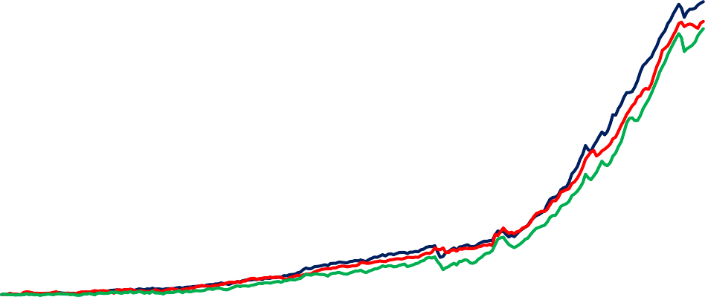

1760 1810 1860 1910 1960 2010

1800

1600

1400

1200

1000

800

600

400

200

0

Productivity Real wages GDP per head

Sources: Bank of England, ‘A millennium of macroeconomic data’, available online.

Notes: Labour productivity per head uses GDP at factor cost. Real wages defined as nominal wage divided by GDP deflator at factor cost.

|  |
| --- |
| **Chart 3: Literacy rates in Western Europe** |
| Sources: OurWorldInData.org, based on Buringh and Van Zanden (2009) and Broadberry and O’Rourke (2010). |
| **Chart 4: Long-run UK GDP growth** |
| Sources: Broadberry and Wallis (2017) and Bank calculations. |

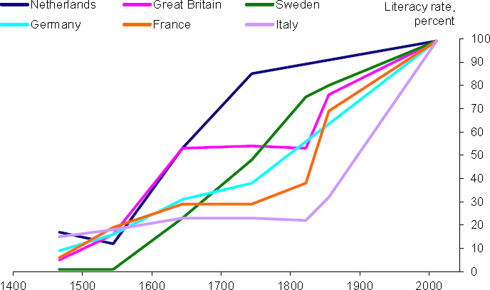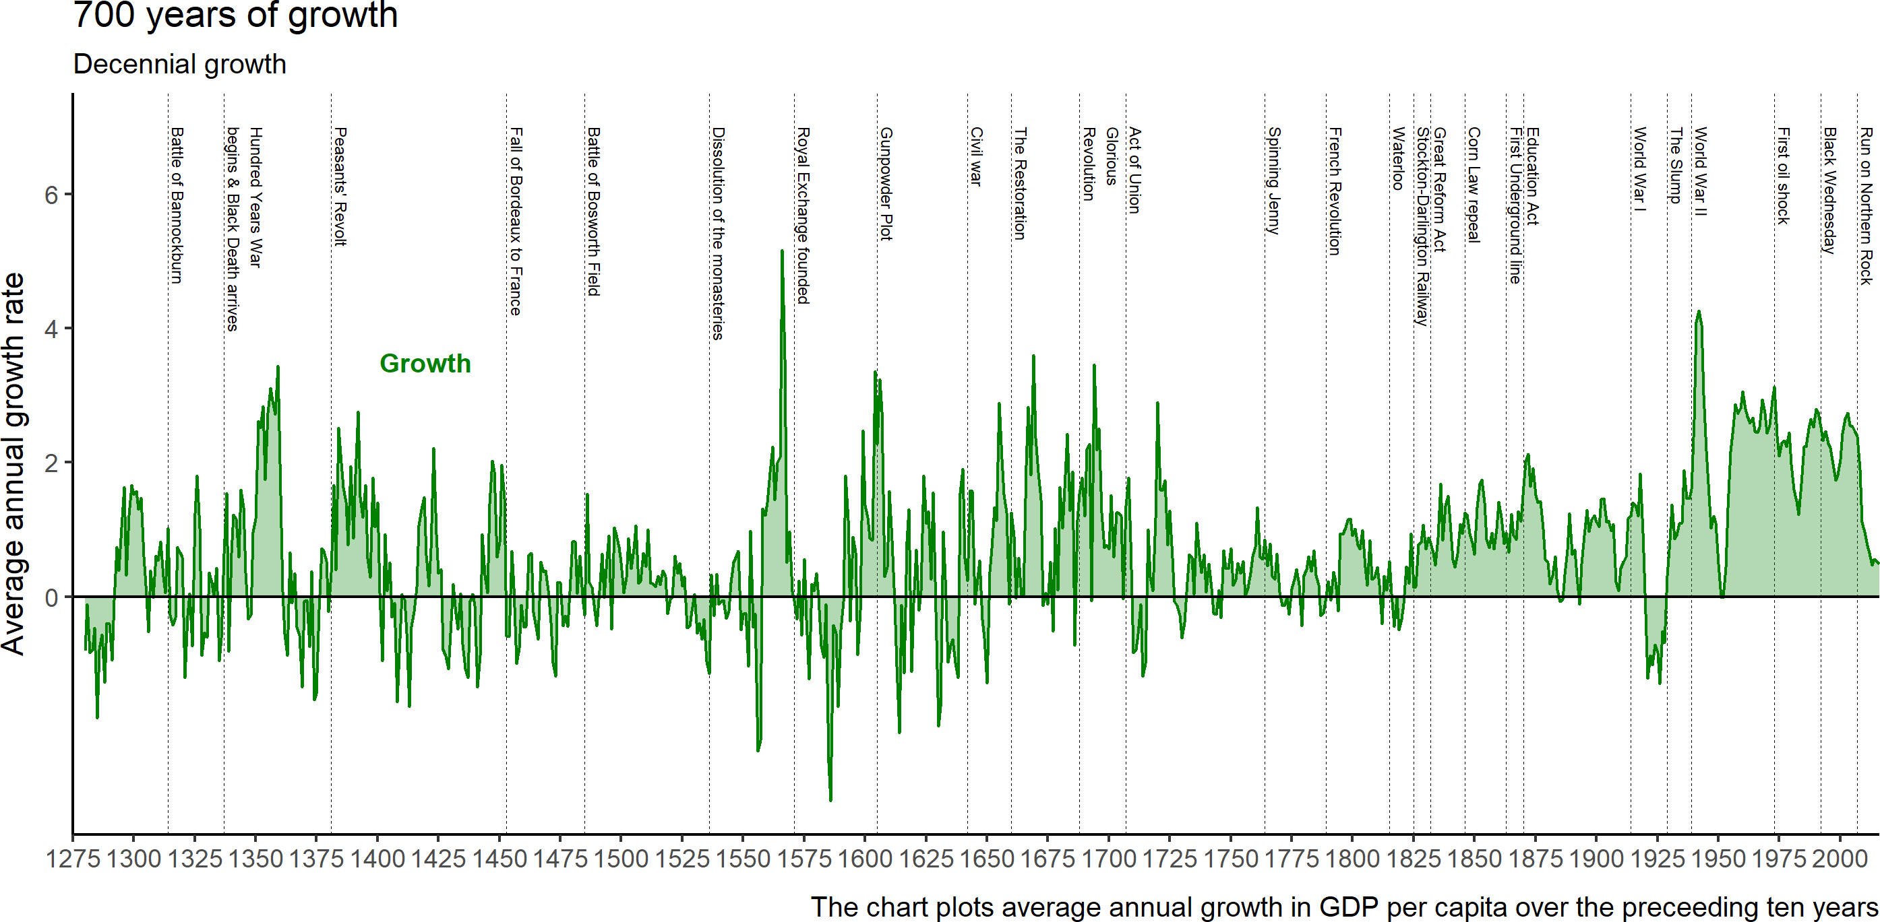

|  |
| --- |
| **Chart 5: Expanding and contracting periods in UK GDP growth** |
| Sources: Broadberry and Wallis (2017) and Bank calculations. |

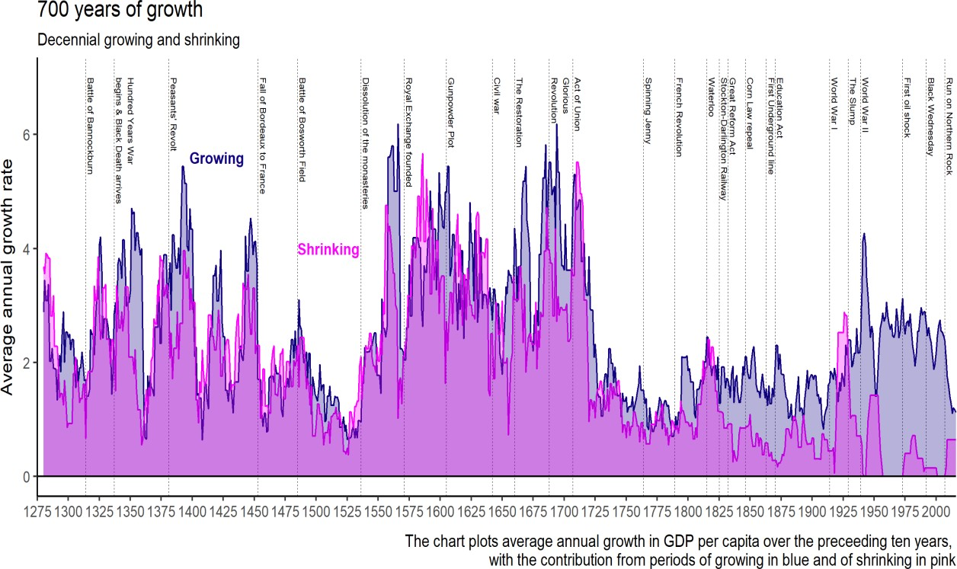

# Table 1: Estimates for Job Destruction and Creation from Automation (MIT (2018))

|  |  |  |  |  |
| --- | --- | --- | --- | --- |
| **When** | **Where** | **Jobs Destroyed** | **Jobs Created** | **Predictor** |
| 2016 | Worldwide |  | 900,000 to 1,500,000 | [Metra Martech](http://robohub.org/wp-content/uploads/2013/04/Metra_Martech_Study_on_robots_2013.pdf) |
| 2018 | US jobs | 13,852,530 | 3,078,340 | Forrester |
| 2020 | Worldwide |  | 1,000,000-2,000,000 | Metra Martech |
| 2020 | Worldwide | 1,800,000 | 2,300,000 | Gartner |
| 2020 | Sampling of 15 countries | 7,100,000 | 2,000,000 | World Economic Forum (WEF) |
| 2021 | Worldwide |  | 1,900,000-3,500,000 | The International Federation of Robotics |
| 2021 | US jobs | 9,108,900 |  | Forrester |
| 2022 | Worldwide | 1,000,000,000 |  | Thomas Frey |
| 2025 | US jobs | 24,186,240 | 13,604,760 | Forrester |
| 2025 | US jobs | 3,400,000 |  | ScienceAlert |
| 2027 | US jobs | 24,700,000 | 14,900,000 | Forrester |
| 2030 | Worldwide | 2,000,000,000 |  | Thomas Frey |
| 2030 | Worldwide | 400,000,000-  800,000,000 | 555,000,000-  890,000,000 | McKinsey |
| 2030 | US jobs | 58,164,320 |  | PWC |
| No Date | US jobs | 13,594,320 |  | OECD |
| No Date | UK jobs | 13,700,000 |  | IPPR |

Source: MIT Technology Review (2018) - [https://www.technologyreview.com/s/610005/every-study-we-could-find-on-what-automation-](https://www.technologyreview.com/s/610005/every-study-we-could-find-on-what-automation-will-do-to-jobs-in-one-chart/) [will-do-to-jobs-in-one-chart/](https://www.technologyreview.com/s/610005/every-study-we-could-find-on-what-automation-will-do-to-jobs-in-one-chart/)

# Chart 6: Wage premium for cognitive skills

Real wage level of full time U.S. male workers relative to 1963

2.0

High School Dropout High School Graduate

Some College

Bachelor's Degree

Greater than Bachelor's Degree

1.8

1.6

1.4

1.2

1.0

1963 1968 1973 1978 1983 1988 1993 1998 2003 2008

Sources: Autor (2014).

# Chart 7: Productivity levels relative to the US

0.8

Per cent

AEs EMEs

World

1950 1958 1966 1974 1982 1990 1998 2006 2014

100%

90%

80%

70%

60%

50%

40%

30%

20%

10%

0%

Sources: Penn World Tables 9.0 and Bank calculations. Notes: Median TFP level at current PPPs; USA = 1

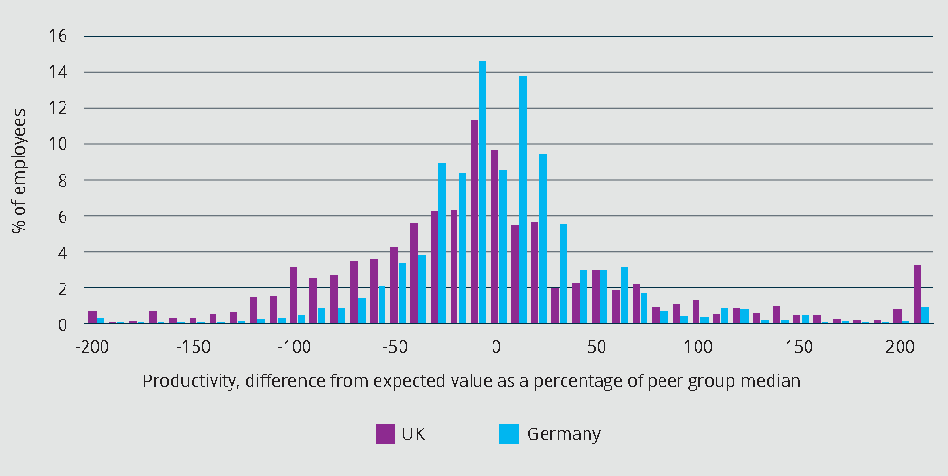

r cent

100

90



80

70

60

50

|  |  |  |
| --- | --- | --- |
| **Chart 8: UK and Germany firm-level productivity (Productivity Leadership Group (2017)** | **)** |  |
| Sources: McKinsey & Company Inc. analysis of Orbis (2013) data, as shown in Productivity Leadership Group (2017) Available at: <https://www.bethebusiness.com/wp-content/uploads/2018/04/how-good-is-your-business-really.pdf> | . |  |
| **Chart 9: Enterprises’ broadband connectivity by firm size in 2016 for OECD countries** |  | Pe |
|  |  |  |
|  |  |  |
|  |  |  |
|  |  |  |
|  |  |  |
| All enterprises 10-49 employees 50-249 employees 250+ employees |  |  |
| Sources: OECD |  |  |